## **2.2 Analysis Methodology**

Analysis Methodology is a method or procedure that analyzes problems, applies data analysis system functionality and also interprets result of data analysis. As there are various methodology for software development and some of them are soft system methodology, hard system methodology and so on. I am going to use soft system methodology.

**Soft System Methodology (SSM)**

Soft System Methodology is an approach that can be used to solve general problem and manage changing in the organization. These methodology learns and appreciate the problem and gives soft analysis on the process that system should operate and the way system should do it. This helps in improving the processes when the time comes to making decision.

There are several stages that carry out the processes of Soft System Methodology. The six stages are shown below:

**Stage 1: Finding out**

It tries to understand the problem situation content and context as write as possible by using interviews, observations and workshops.

A group of people were interviewed with the following questions

* What is their methods for getting their airline tickets?
* Do they use applications or websites for booking airline tickets? Why?
* How often do they make airline ticket reservation online?

From the above survey following information were found.

* Most people manually make reservation to airline ticket either by vising the ticket department at the airlines or by making a verbal communication.
* Among the people who make online reservation, most people use android application.
* Websites are often slow in processing or always down in case of some people.
* People often waste a lot of time by manually visiting the local airlines

**Stage 2: Expressing the problem situation**

This stage includes the validation and communication of the problem situation. A different tools can be used for achieving the problem. But the main technique to achieve it is “Rich Picture”.

**Rich Pictures** are the unstructured pictures which communicates every ideas we think of the problem situation that we are analyzing.

The Rich Picture of the situation is shown below:

* Admin

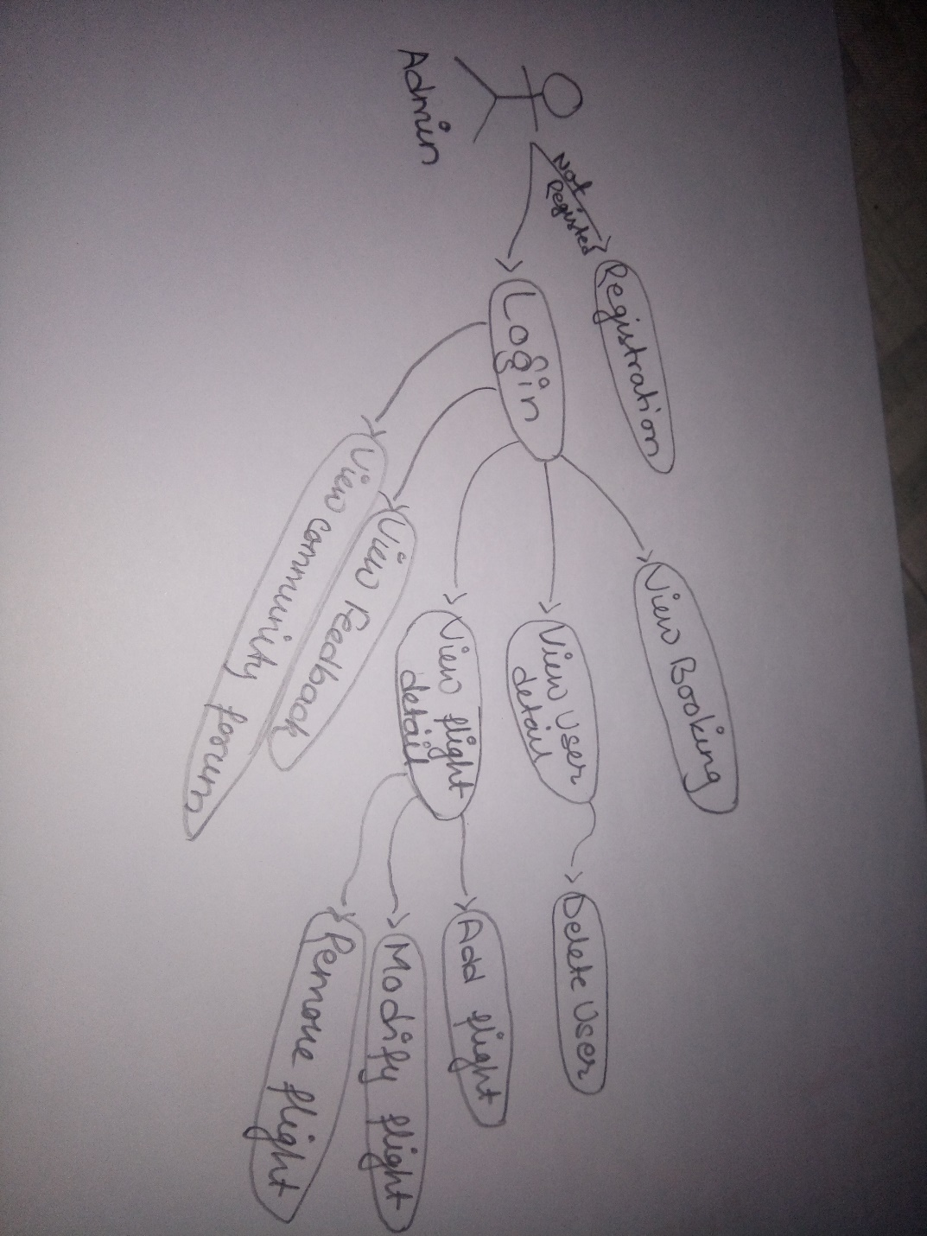

* User

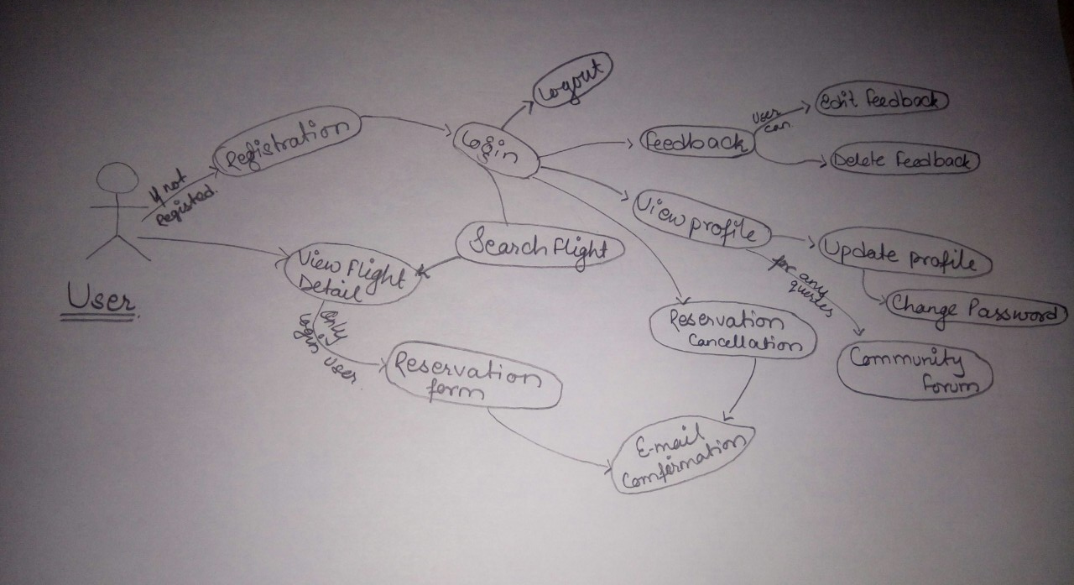

**Stage 3: Deriving Root Definitions:**

Root definition is the definition of the definition of the purpose that names a system. These are of short statements that explains the functions and aims of the system needed for its development.

For producing root definitions two steps are included:

1. Input-Output transformation diagrams.

It separates the different purposes of the system and reflects many perspectives.

1. CATWOE framework.

The CATWOE is a checklist for discovering solutions to the problems. It stands for **C**ustomer, **A**ctors, **T**ransformation, **W**orldview, **O**wner and **E**nvironmental. CATWOE Framework is used for producing a root definition for each transformation.

CATWOE analysis have been conducted in my project to give the following result.

**C**= Customers or flight attendees

**A**=Airlines Staffs

**T**=Flight Attendees can directly reserve their flight tickets and communicate with airlines staffs.

**W**=People can save their time of manually going to book their tickets and can spend that time on resourceful tasks

**O**=Airlines System

**E**=Educational Environment

**Root Definition**

A system owned by the Airlines where customers or flight attendees can make reservation of their required tickets online and communicate with airlines staffs gradually saving their time as well as costs that may occur by manually making reservations.

**Stage 4: Deriving Conceptual Models:**

A conceptual model can be defined as a method of analyzing activities that helps in knowing what the actors are needed to perform for the achievement of the transformation. Different activities are listed and related graphically for designing a conceptual model.

The conceptual model for my project is given below.

* Admin

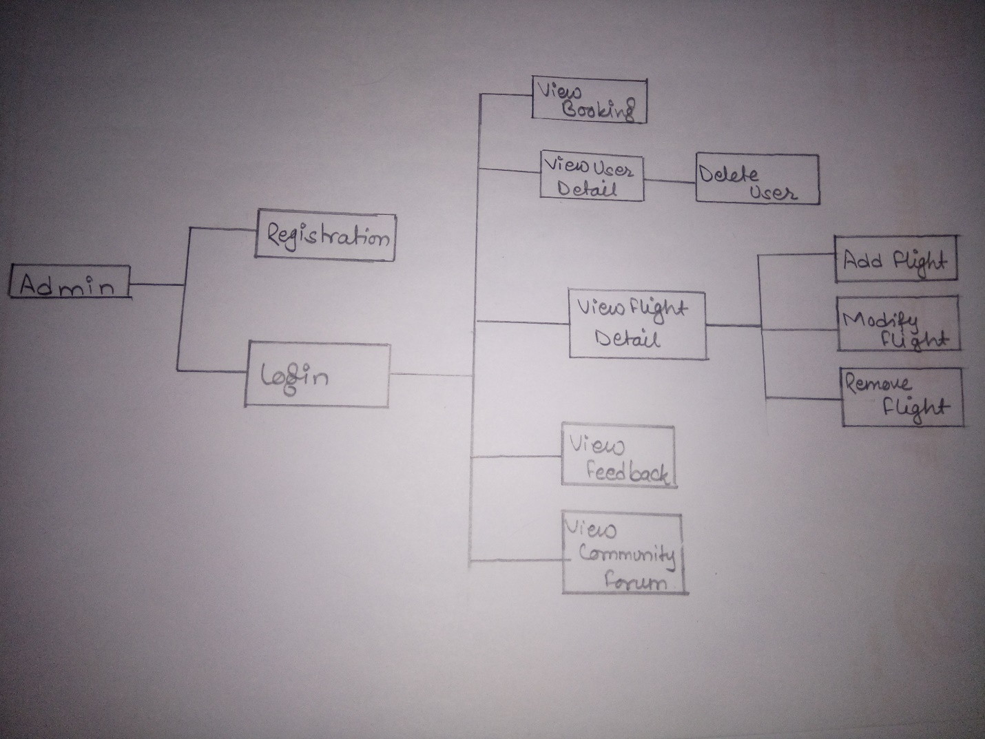

* User

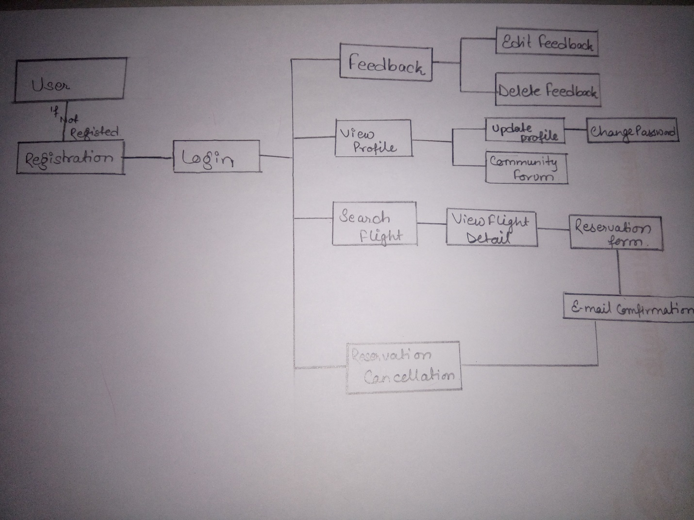

**Stage 5: Comparing Conceptual Models with the Real World:**

In this stages Conceptual model is compared with real world as not all the things are perfect this stage provides a feedback on changes that are needed to be made to existing system.

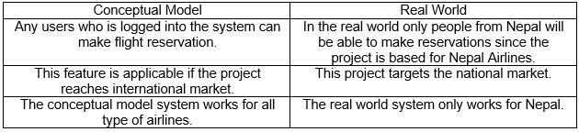

**Stage 6: Analyzing Feasible and Derivable change**

This stage follows the activities to represent the conceptual diagram and rich picture to the stakeholder of the project and some other users who can give helping hard in analyzing the system model with the diagrams shown above. The project has not yet included any features of providing advantages to users who have used the system for a long time. A desirable change that is brought up is to provide feasible facilities to users who are constant users of the online system